Complete, sign, date & return this page only to Ms. Ivery tomorrow.

Ms. Ivery, STEAM Research Educator | Belair Middle School | Room 604 | Phone: 706-737-7301

Online Teacher Page: <https://www.rcboe.org/Domain/20976> E-mail: [IveryTa@richmond.k12.ga.us](mailto:IveryTa@richmond.k12.ga.us)

**Acknowledgement**

Please complete, sign and date this page of the syllabus to affirm that you and your scholar have reviewed this document.

Scholar’s Name (Print) ­­­­­­­__________________________________

Parent/Guardian Name (Print) ____________________________ Date _____________________________

Parent/Guardian Signature ­­­­­­­­­_______________________________

Parent/Guardian Phone Number __________________________ E-mail ____________________________

­­Preferred Method of Communication: _____ Phone _____ E-mail

**Checklist**

**As you read over the syllabus, please initial on the check list; and complete, sign, and date where needed and return this top page to Ms. Ivery tomorrow.**

­­_____ 1. My scholar and I have reviewed the Academic Honesty, Missing Work and Late Work policies.

_____ 2. I have registered my scholar in Parent Portal Infinite Campus and I understand that this is where I check grades, including missing assignments.

_____ 3. I understand that if my scholar is absent, it is his/her responsibility to get with Ms. Ivery for all missing assignments.

­­_____ 4. I understand that extra credit will only be given to the entire class at Ms. Ivery’s discretion.

_____ 5. I understand that my scholar must come to class every day prepared with the suggested materials and ready to learn.

_____ 6. I understand that if I would like to schedule a Parent-Teacher Conference, I must book it through <https://www.rcboe.org/Page/20976> or call the Guidance Department to do so.

_____ 7. I have reviewed the entire syllabus and understand Ms. Ivery’s rules and expectations.

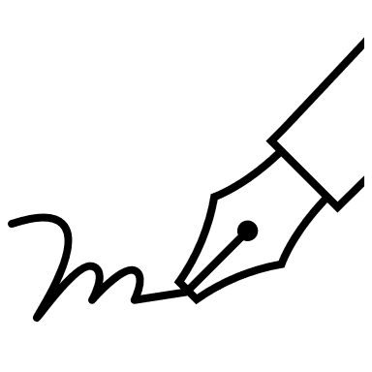**A note from the teacher:**

Hello Parents and Guardians,

My name is Ms. Ivery. I am very excited to teach your scholar STEAM Research this year. I believe that educators need to work closely with parents and scholars to provide a positive atmosphere of communication and consistency. I am confident that we are going to have a productive and successful school year. Thank you in advance for your support, and I look forward to a terrific year here at Belair Middle School! ~Ms. Ivery

**Grading Scale**

Grades are determined on your performance in classwork, on challenges & projects. Homework is any classwork that is not completed during class. This does not include Asynchronous Days (Learn From Home Days).

The computer will automatically round up semester grades that are within 0.05 points of the higher grade.

***Want to know how your scholar is doing in my class?*** Check **Infinite Campus**. All grades will be posted online in Infinite Campus weekly. Parents are encouraged to monitor their scholar’s grades using the RCSS Parent Portal, Infinite Campus.

|  |  |
| --- | --- |
| A | 90%-100% |
| B | 80%-89% |
| C | 75%-79% |
| D | 70-74% |
| F | Below 70 |
| F | No attempt |

Ms. Ivery, STEAM Research Educator | Belair Middle School | Room 604 | Phone: 706-737-7301

Online Teacher Page: <https://www.rcboe.org/Domain/20976> E-mail: [IveryTa@richmond.k12.ga.us](mailto:IveryTa@richmond.k12.ga.us)

**Academic Honesty**

RCSS Code of Conduct, Rule 1 (A)(t), states that no student shall cheat, alter records, plagiarize, receive unauthorized assistance, or assist another in any type of academic dishonesty. The unauthorized or improper use of an artificial intelligence (AI) program constitutes academic dishonesty.

The determination that a student has engaged in academic dishonesty will be based on the judgment of the classroom teacher and a supervising administrator, taking into consideration any written materials, observation, or information from witnesses. Scholars found to have engaged in academic dishonesty will be subject to disciplinary actions as outlined in the Student Code of Conduct. Additionally, the assignment may be entered as “incomplete” where the scholar will have to redo an assignment or retake an assessment; or a ”zero” where the parent will be contacted and the next steps will be discussed.

**Grading Weights**

|  |  |
| --- | --- |
| Minor Assignments – classwork, challenges & formative tests | 60% |
| Major Assignments – challenges, projects, summative tests | 40% |

**Missing Work**

Missing work is to be made up at the discretion of the teacher. It is the **scholar’s responsibility** to contact Ms. Ivery regarding make-up work. Scholars who fail to see Ms. Ivery and schedule a time to make up missed work may receive a grade of zero for that missing assignment. A scholar has only 5 days to make up missing work. However, Ms. Ivery will determine re-assigned work on a specified date.

**Late Work**

Late work is defined as assignments that are submitted after the specified deadline. This does not apply to work submitted late due to an excused absence from school.

Scholars are expected to submit all assignments on time. Scholars will receive a 5% grade reduction per school day for a 25% maximum reduction (five school days). Any assignments submitted after the fifth school day will only be accepted at Ms. Ivery’s discretion.  **I will not accept late work from a previous grading term or unit**.

**Overview**

STEAM Research class combines Science, Technology, Engineering, Arts, and Mathematics into the curriculum, engaging scholars in hands-on experiences and experiments. This approach fosters a culture of curiosity and discovery.

***Want to know what your scholar will be learning?***

|  |  |
| --- | --- |
| Unit 0: | **Think STEAM.** |
| Unit 1: | **Ask.** Identify & define problems and constraints. |
| Unit 2: | **Imagine.** Brainstorm, research & choose best ideas. |
| Unit 3: | **Plan.** Design & create a blueprint. |
| Unit 4: | **Build, Test, Evaluate.** Develop a model. |
| Unit 5: | **Revise, Redesign, Share.**  Adjust for better results. |

**Classroom Expectations**

Appropriate behavior is always expected as this provides an academic and safe environment conducive to developing the skills necessary to succeed in class. Each scholar must follow the RCSS Code of Conduct, Belair Middle School procedures, and Ms. Ivery’s class rituals and routines. Further disruptions will result in contact with parents. If that is unsuccessful, further disciplinary action will be taken. **You** must:

1. Follow all of Ms Ivery’s instructions.
2. Give 100% of effort all the time.
3. Enter the classroom quickly and quietly to start on time.
4. Respect yourself and others in speech and behavior.
5. No food or drinks in class, unless approved.
6. Be prepared with ALL materials daily.
7. Raise your hand for permission to get out of your seat and leave the class outside of Ms. Ivery’s instruction and appointed timeframe.
8. No cell phone/other personal electronic devices in class. *Parents be mindful of texting your scholar during class as YOU may be the cause of disruption. Do not expect a response. Call the front office instead at 706-737-7301.*

**1 Rule Classroom**

If what you are doing:

**INTERFERES** with learning,

**HURTS** someone’s feelings/heart OR

**PREVENTS** you from being your best self,

**YOU SHOULDN’T BE DOING IT, so DON’T.**

Ms. Ivery, STEAM Research Educator | Belair Middle School | Room 604 | Phone: 706-737-7301

Online Teacher Page: <https://www.rcboe.org/Domain/20976> E-mail: [IveryTa@richmond.k12.ga.us](mailto:IveryTa@richmond.k12.ga.us)

**Communication**

 Richmond County School System utilizes Canvas as our learning management system.  For additional class information, announcements, and assignments, please refer to Canvas.

 Richmond County School System utilizes Infinite Campus as our parent portal.  For schoolwide announcements, parent-teacher-student messaging, and registering your child, please refer to Infinite Campus.

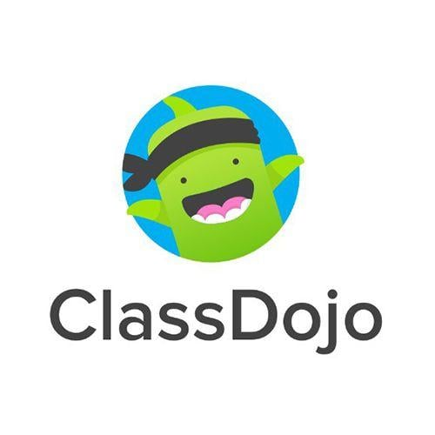 I utilize ClassDojo as a speedy messaging system for both parents and scholars.  Please refer to ClassDojo for homework reminders, school events, and quick correspondences.

Please allow up to 48 hours for a response during my office hours, Wednesdays and Fridays 11:30 am-12:30 pm.

**Consequences**

Scholars are free to **choose**, but they are not free of the **consequences**. Scholars who do not meet the expectations and rules of RCSS Code of Conduct, Belair Middle School procedures and Ms. Ivery’s class rituals and routines will proceed with the following disciplinary plan:

1. Verbal Warning 2. Redirection + Lose ClassDojo points 3. Reflection Essay + Major Referral 4. In-person Parent Conference

**Parent-Teacher Conferences**

All conferences, including IEPS and 504s, must be scheduled through Booking or the Guidance Department.

Copy + Paste: <https://www.rcboe.org/Domain/20976>

Call: 706-737-7301